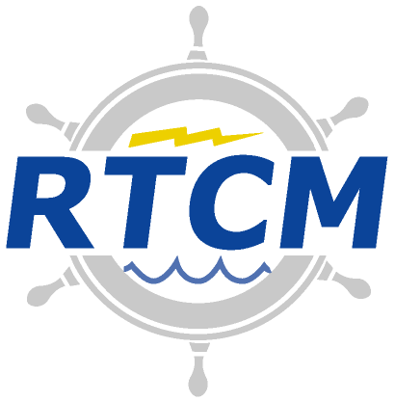
Radio Technical Commission for Maritime Services
1621 N Kent St, Suite 705
Arlington, Virginia 22209
www.rtcm.org hq@rtcm.org

Telephone: +1-703-527-2000 Telefax: +1-703-351-9932

September 20, 2018
Dear RTCM SC-134 Members:

This letter is to inform you of the an RTCM Special Committee (SC) 134 Plenary meeting, which will be held in Frankfurt, Germany on October 15-16, 2018. The meeting will be held at Steigenberger Hotel Metropolitan in Frankfurt, Germany (Poststrasse 6, 60329 Frankfurt, Germany, +49 69 506070-0). The room number and other similar details are still being determined: see the http://rtcm.info/sc134/ papers page for updates on such details.
It is IMPORTANT to note that the meeting will begin at 11:00 AM on Monday, Oct. 15 as decided by the committee so as to allow many committee members to arrive early Monday morning. On the second day (i.e., Tuesday, 16 October 2018), the meeting will start at the normal 9:00 AM.
Attached is the Meeting Notice and Tentative Agenda.
The main objectives of the meeting will be the following:
- WG1 Status Update
- WG2 Status Update
- WG3 Status Update
- Possible change to the WG3 Chair
- WG4 Status Update
- Discussions concerning formation of new WGs
Please review the documents listed in the Meeting Notice and bring them with you along with other relevant documents. I would suggest that you check the RTCM SC-134 papers page (http://rtcm.info/sc134/) for new or updated document postings prior and the meeting.

Sincerely,

Kendall Ferguson

RTCM SC-134 Chair

kferguson@rtcm.org

+1-540-446-8982
Meeting Notice

RTCM Special Committee No. 134

Integrity Monitoring for High Precision Applications

Time/Date: 11:00 AM – 5:00 PM, Monday, 15 October 2018
9:00 AM – 5:00 PM, Tuesday, 16 October 2018

Location: Steigenberger Hotel Metropolitan
Poststrasse 6, 60329 Frankfurt, Germany
+49 69 506070-0
(see http://rtcm.info/sc134/ for updates on details)

NOTE: If you are attending the meeting, please bring one electronic copy of any new document you produce. Key documents which you should have for use at the meeting include:

- RTCM Paper 097-2018-SC134-016 (Meeting Notice for October 15-16, 2018 - this document)*
- RTCM Paper 096-2018-SC134-015 (June 2018 Meeting Summary Report)
- RTCM Paper 225-2013-BD-508 (Bylaws of RTCM)
- RTCM Paper RTCM paper 226-2013-BD-509 (RTCM Standards Development Policies)

* Check for updates to these documents and additional document postings prior to the meeting

There may be other documents generated between now and the meeting, so please check the web site (URL to be announced) for papers before you leave for the meeting.

Open Action Items from the June 2018 Plenary Meeting
Action Item | Description | Responsibility | Review Date
SC-134-008 | Kendall will contact BoD about the name change to this committee. | Kendall Ferguson | July 2018
SC-134-007 | Kendall will work on getting a conference room and remote access for the next meeting in Frankfurt, October 15-16. | Kendall Ferguson | July 2018
SC-134-004 | ISO has already dependent “Smart City” standards/references that might be used in the formulation of this group’s work | by Dr. Mireille Elhajj (Imperial College London) | October 2018

RTCM SC-134 Plenary Meeting

11:00 AM – 5:00 PM, Monday, 15 October 2018

9:00 AM – 5:00 PM, Tuesday, 16 October 2018

TENTATIVE AGENDA

- Welcome – Ed Wendlandt, RTCM President
- Introduction of Attendees – Kendall Ferguson, SC-134 Chair
- Goals and Agenda – Kendall Ferguson, SC-134 Chair
- Patent Disclosure – Kendall Ferguson, SC-134 Chair
Chairmen of Special Committees will ask, at an appropriate time in each meeting, whether anyone has knowledge of their own or other organizations’ patents, including published pending patents, the use of which may be required to practice or implement the standard being considered. The fact that the question was asked shall be recorded in the meeting summary record, along with any affirmative responses.
- WG1 (Automotive) Status and Progress – Kerry Greer, Automotive WG Chair
- WG2 (Rail) Status and Progress – Salvatore Sabina, Rail WG Chair
- WG3 (Other Applications) Status and Progress – Roberto Capua, Other Applications WG Chair
- WG3 (Other Applications) Chair Position – Kendall Ferguson, SC-134 Chair
- WG4 (Harmonization of Requirements and Metrics) Status and Progress – Roberto Capua, Harmonization of Requirements and Metrics WG Chair
- New SC 134 Work Areas – Roberto Capua, SC-134 Vice Chair
- Next Meeting (date and venue) – Roberto Capua, SC-134 Vice Chair
- Other Business – Roberto Capua, SC-134 Vice Chair
- Meeting Action Items Review – Kendall Ferguson, SC-134 Chair

