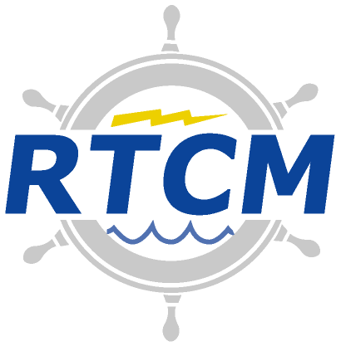
Radio Technical Commission for Maritime Services
1621 N Kent St, Suite 705
Arlington, Virginia 22209
www.rtcm.org hq@rtcm.org

Telephone: +1-703-527-2000 Telefax: +1-703-351-9932

April 17, 2018

Meeting Summary Record

RTCM Special Committee No. 134

Recommended Standards for Integrity Monitoring of High Precision Applications

Time/Date: 11:00 AM – 12:00 PM, Tuesday, April 17th (GMT – 4)

Location: Teleconference – Call in credentials provided by Joe Sass

The RTCM Special Committee 134 had its initial discussions between the chair, vice-chairman, and potential secretary of this new committee. Notes were taken by the proposed secretary. Primary goals of the discussion were:

- Seek inputs about launching SC-134

Document Contents:
- Summary Record
- APPENDIX 1: Meeting Attendance Record
- APPENDIX 2: RTCM SC-134 Working Groups
- APPENDIX 3: Table of Open and New Committee Action Items

RTCM SC-134 Telephone Meeting/Discussion

SUMMARY RECORD

- Inputs regarding committee launch

Joe Sass suggests an announcement be made in Harbin with a plan to host a meeting soon thereafter in Europe. Roberto Capua has replied that it could be possible that the meeting be hosted by his company in Rome. Kendall Ferguson asked if there was another conference that would attract these people that could be held in conjunction with a kick-off meeting. Joe suggested RTCM make an announcement about the committee’s formation and include date and venue for kick-off meeting. Kendall proffered the SAE Automated and Connected Vehicle Systems Testing Symposium, June 20-21, 2018 │ Greenville, SC, USA

Roberto stresses the importance of trying to include Stanford University, as they are considered the grandfathers of integrity.

Kendall states that one day should be sufficient. He noted the important topics of processes and rules of the committee. That is, should they be modeled after SC-104 or some other approach? For example, other organizations use something akin to rounds, where by round 5, for example, must be completed before round 6 may be completed. However, multiple rounds may be worked on simultaneously. This might discourage activities that lead to stalemates on any particular topic. Another organizational and working tool used within SC-104 are Working Groups? It was noted that this may not be needed initially. Regardless, the first SC-134 meeting agenda will this committee processes and procedure debate.

Joe and Roberto disagree about one day being enough and think 1.5 days is probably better.

Estimates about the number of attendees ranges from very low numbers up through 30. Roberto’s company will be the first plan for the initial meeting. Joe Sass suggested that perhaps Trimble Paris or Trimble Nantes could be a backup venue.

Roberto encourages and stresses the importance of liaisons with other companies such as RTCA. Kendall adds agreement with an example of SAE and indicated that such would be discussed during the coming SC-134 meetings.

Kendall has agreed to form the initial agenda for the kick-off meeting and send this to Roberto and Joe for review and augmentation.

- Fee structure for SC-134
Kendall related that some RTCM committee members believed that costs will be higher than other committees due to its involvement with other standards committees.

- Details regarding kick-off meeting
First meeting of this committee to be held on Wednesday and Thursday, June 20-21, 2018 in Rome, Italy. Tentatively, Roberto’s company will host the event. RTCM has agreed that if Roberto’s company cannot host the event, they will sponsor the kick-off meeting there regardless.

APPENDIX 1: Meeting Attendance Record – April 17, 2018 – Teleconference
Name | Organization | Phone/E-Mail
Kendall Ferguson | Sapcorda | +1-540-446-8982  kferguson@rtcm.org
Joe Sass | Spectra Precision | +1 909 553 5582  joe_sass@spectraprecision.com
Roberto Capua | Sogei SPA | +390650253428  rcapua@sogei.it

APPENDIX 2: RTCM SC-134 Working Groups

APPENDIX 3: Table of Open and New Committee Action Items (April 16, 2018)
Action Item | Description | Responsibility | Review Date
SC134-01 | Kendall will contact Bob Markle to discuss how best to announce SC-134 creation to RTCM members. Can it include date and venue information for kick-off meeting? Can an RSVP be required to estimate numbers attending? | Kendall Ferguson | May, 2018
SC134-02 | Kendall will request from Bob Markle a web site for SC-134. There is a possibility that the new web space can be modeled after the previous SC-104 site which worked well for many years. | Kendall Ferguson | May, 2018

